10 Linux Commands
1.tac
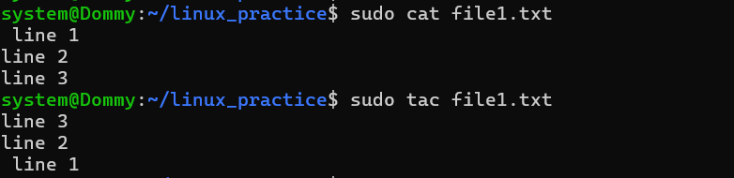
2. whereis
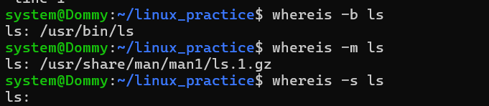
3. look
4.mv
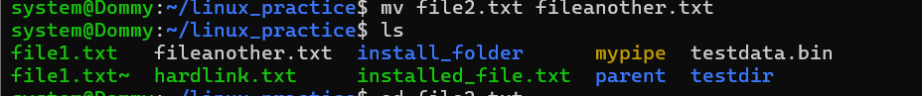
5. od
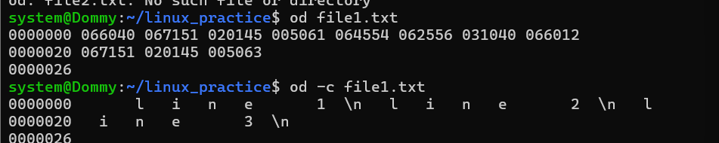

6.paste
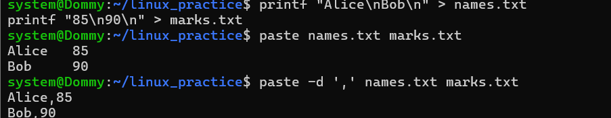
7.readlink
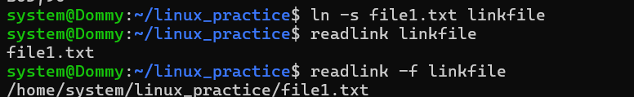
8. rev
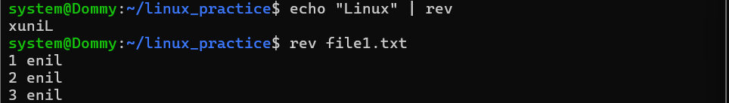
9.shred
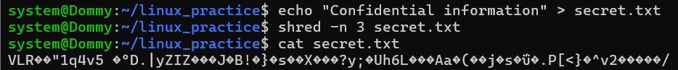
10.uniq
